Module 2a

How do the national frameworks support professional development?

Let’s begin

Reflection
Note: In this professional learning we use ‘education setting’ in place of ‘school’, so that teachers across diverse contexts are included.
What impact would implementing effective performance and development practices have on your education setting?

What is the Australian Teacher Performance and Development Framework?
The Australian Teacher Performance and Development Framework (the Framework) outlines a national approach to supporting teacher performance and development. It examines how to build a culture of development and the continuous cycle of development.
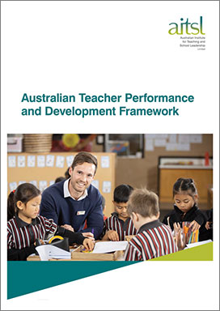
The Framework was developed in collaboration between AITSL and education stakeholders, and is based on research, national mapping and extensive consultation.
In this module we will look at what the Framework says about effective performance and development and how it applies to your education setting.
Further reading: Read the Australian Teacher Performance and Development Framework in full, look at Unpacking the Australian Teacher Performance and Development Framework and download FAQ document about the Framework.

What makes effective performance and development?
The Framework outlines the performance and development cycle, and how it sits within a wider performance and development culture. Watch this 6 min animation for an overview.
https://www.youtube.com/watch?v=EjMBxxNaboE

Video notes

Reflection
What current development practices are working well in your education setting? What practices could be strengthened?

What components of the Framework can you already see in action in your education setting?

What is a performance and development culture?
Research shows that a successful approach to effective performance and development relies on creating a strong and supportive culture in an education setting. The five components of a successful approach to development culture are outlined in dark green here:
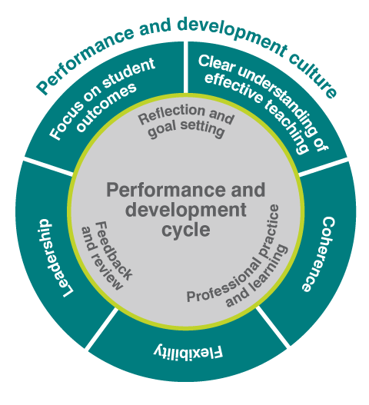
To introduce and sustain effective performance and development, a culture must exist among leaders and teachers that promotes feedback and is serious about performance and development. A culture that supports effective professional learning and the routine practice of performance and development will be characterised by:
- a high degree of leadership support for ongoing adult learning and risk taking
- collective responsibility for improving practice
- disciplined collaboration aimed at specific and relevant goals that relate to the learning needs of students
- high levels of trust, interaction and inter-dependence
- support for professional learning through school structures, explicit planning and the allocation of time
- a focus on the professional learning most likely to be effective in improving professional practice and learner outcomes.
Further reading: Read the Australian Teacher Performance and Development Framework

Benefits of a performance and development culture for teachers and leaders
Benefits for teachers
- supports whole-setting teacher improvement, leading to improved learner outcomes
- develop understanding of and alignment with education setting’s improvement goals
- increased professional growth through coaching and mentoring
- increase in professional satisfaction
- access to networks through system-wide collaboration
- access to:
  - relevant professional learning
  - targeted career goal setting
  - effective reflection and feedback
  - collegial networks.
Benefits for leaders
- drives a whole-setting approach to teacher improvement
- drives improvement in education settings
- develop whole-school improvement goals aimed at improving learner outcomes
- promotes collaboration
- encourages leadership at all levels
- promotes a shared commitment to excellence
- shared understanding of effective teaching
- promotes setting-wide processes for professional learning.
Further reading: Download a two-page factsheet

Reflection
Which of the benefits listed above would make the biggest difference in your education setting?

The components of a performance and development culture
Focus on student outcomes. Improving teaching is not an end in itself, but it is aimed at improving outcomes for learners. The Framework defines student outcomes broadly to include student learning, engagement in learning, and wellbeing. These can be measured in a variety of ways.
Clear understanding of effective teaching. The Australian Professional Standards for Teachers (the Teacher Standards) outline what teachers should know and be able to do at four career stages. The Teacher Standards provide the basis and a common language for coming to a shared understanding of what effective teaching looks like, in the context of a particular education setting at a particular time.
Leadership. Research is clear on the critical role of leaders in creating a culture of performance and development. While principals have a central role, a truly effective approach has a shared commitment from teachers for their own – and each other’s – development.
Flexibility. All education settings have different contexts and histories. There isn’t a one-size-fits-all approach, and performance and development will look different across unique settings.
Coherence. Goals and processes should reflect the overall approach to teaching and learning within an education setting and should be consistent with the existing plans and approaches.

Reflection
Identify existing processes within your education setting that support the five components of a performance and development culture.
Component | Examples
Focus on student outcomes
Clear understanding of effective teaching
Leadership
Flexibility
Coherence

How do you grow and sustain a performance and development culture?
Education settings operate in different contexts and will have different starting points, with differing implementation needs.
It is in the ongoing work of implementation and culture change that the real challenge lies. There needs to be a strong commitment from, and extensive support for:
- education settings
- groups of education settings
- teachers
- leaders
- the wider education setting community.
Monitoring and evaluation are also essential to sustained and successful implementation.

Reflection
What opportunities and potential barriers can you see in building on the performance and development culture within your education setting? How can you improve the processes currently in place?

Professional conversation
After spending time reflecting individually, seek out a colleague, mentor or leader to discuss your thoughts. Use the above questions and your responses to help structure the conversation.

What is the performance and development cycle?
The teacher performance and development cycle provides a structure for developing and refining teaching practice. The three components of the cycle are interdependent and may not necessarily occur in a set order, or take equal time, but the cycle provides a useful way to structure your thinking about how to improve practice. The components are highlighted in light green here:
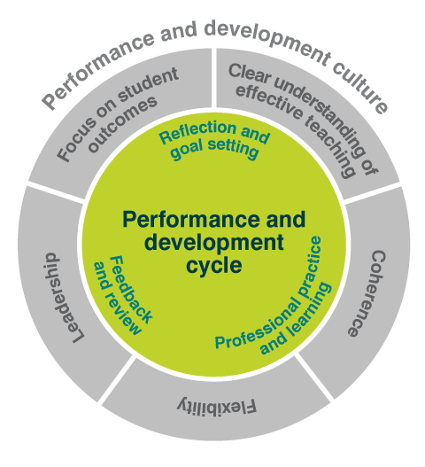
Reflection and goal setting, with regular reviews of measurable goals. Goals should align to an education setting’s shared view on effective teaching and should take teacher reflection into account.
Professional practice and learning, meaning teachers will make a conscious effort to collect and reflect on evidence. It should occur in a context of frequent formal and informal feedback.
Feedback and review, with feedback being timely, frequent and improvement focused. There should also be a formal annual performance and development review, including a full reflection on a teacher’s performance against their goals using multiple sources of evidence.

Reflection
Identify existing processes within your education setting that support the three performance and development cycle practices outlined in the Framework.
Components | Examples
Reflection and goal setting
Professional practice and learning
Feedback and review

Essential elements for performance and development
There are four elements essential to an effective cycle of performance and development. These have been distilled from the research, practitioner advice and an analysis of current good practice.
Goal setting: All teachers have a set of documented and regularly reviewed goals related to both performance and development, and ways of measuring progress towards them, that are agreed with leadership.
Professional support: All teachers are supported in working towards their goals, including through access to high-quality professional learning.
Evidence collection: Evidence used to reflect on and evaluate teacher performance, including through the formal review described in ‘Feedback and Review’, should come from multiple sources and include as a minimum: data showing impact on learner outcomes; information based on direct observation of teaching; and evidence of collaboration with colleagues.
Feedback and review: All teachers receive regular formal and informal feedback on their performance. This includes a formal review against their performance and development goals at least annually, with verbal and written feedback being provided to the teacher.

What are the roles of teachers and leaders in implementing effective development?
Teachers, leaders, principals, systems and sectors have a shared responsibility to implement effective performance and development.
- Development should be well aligned with other policies and processes at the national, jurisdiction, system and education setting level. It should also reflect the needs and aspirations of the wider education setting community.
- Development should support career progression, including through formal processes such as promotion and certification as a Highly Accomplished or Lead teacher.
- Monitoring and evaluation, including feedback from the education setting community, fosters a sustained and successful implementation.
- Understanding of Indigenous perspectives and knowledge is critical to engage effectively with Aboriginal and Torres Strait Islander colleagues, learners, families, and communities. Leaders play an important role in monitoring where individual teachers and whole settings are on their continuum of cultural responsiveness.

The Australian Charter for Professional Learning of Teachers and School Leaders (the Charter)
The Charter outlines what makes professional learning effective so it leads to improved learner outcomes in Australia.
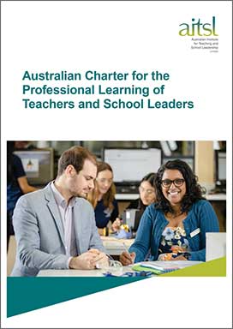
The Charter was informed by research, national and international experts, and extensive consultation with professional associations and the broader education community.
It works alongside the Framework to help teachers and leaders build a successful growth culture.

What does the Charter say about professional learning?
Professional learning should support teachers to reflect on, question and consciously improve their practice. It is most effective when it is:
- relevant
- collaborative
- future-focused
Professional learning is most effective when it takes place within a culture where teachers and leaders:
- expect and are expected to be active learners,
- reflect on pedagogical practice
- receive feedback on and improve their pedagogical practice.
In embedding high quality professional learning practices within education settings, teachers and leaders work together to improve student outcomes. Ongoing learning is essential for teachers throughout their careers, to ensure they meet the current learning needs and aspirations of the diverse learners they teach and the diverse communities they work in.
These characteristics of effective professional learning should be considered when selecting, reflecting on, or evaluating professional learning.

Professional conversations
Identify a colleague, leader or mentor to work through the Charter Stimulus cards.
Further reading: The Australian Charter for the Professional Learning of Teachers and School Leaders and Performance and Development toolkit for teachers overview

Resources and downloads

National frameworks
- Australian Professional Standards for Teachers
- Australian Professional Standard for Principals and the Leadership Profiles
- Australian Charter for the Professional Learning of Teachers and School Leaders
- Australian Teacher Performance and Development Framework

Resources about the Australian Teacher Performance and Development Framework
- Unpacking the Australian Teacher Performance and Development Framework
- FAQs about the Australian Teacher Performance and Development Framework
- Factsheet about the Australian Teacher Performance and Development Framework

Next steps
Deepen your understanding with:
- Module 2b: What is high quality professional learning, and how can it support the development of effective teaching?
Read:
- Putting evidence to work: a school’s guide to implementation
Get into more detail about the development cycle with
- Module 3 – Applying the development cycle to demonstrate proficient against the Teacher Standards
If you haven’t already, complete:
- Module 1 on Understanding the Australian Professional Standards for Teachers to learn more about the Teacher Standards.
Alternatively, return to the
- Quality teaching modules overview page to select another module.

