Module 2b

What is high-quality professional learning, and how can it support the development of effective teaching?

Let’s begin
High-quality professional learning can be formal or informal learning experiences undertaken by teachers and leaders to improve individual professional practice, and an education setting’s collective effectiveness. Purposeful professional learning is one of the most effective ways to improve teaching practices and student outcomes.
Note in this professional learning we use ‘education setting’ in place of ‘school’, to include teachers across diverse contexts.

High-quality professional learning culture
In Module 2a we looked at the Australian Teacher Performance and Development Framework (the Framework) and the Australian Charter for the Professional Learning of Teachers and School Leaders (the Charter). These documents affirm that:
- high-quality learning improves the professional knowledge, practice and understanding of all teachers and leaders
- teacher and leader improvement leads to improvement in student outcomes
- teachers and leaders should actively engage in effective professional learning throughout their careers

Professional learning approaches
Professional learning should be purposeful and align with specific goals. Effective professional learning comes from a range of sources, including:
Classroom-focused
- Observation of practice and feedback
- Coaching
- Mentoring
Research-focused
- Inquiry cycles/action research
- Professional reading
Community-focused
- Professional learning communities
- Networks
- Collaboration based on work samples
Face-to-face
- External events - conferences, training courses and workshops
- Educational setting based events
Online
- Modules and courses
- Webinars/Online forums
A multi-modal approach can be effective – time on professional learning embedded in your daily practice, time spent on self-directed professional learning, and time on face-to-face experiences such as conferences.
Further reading: Read Improving Teacher Professional Learning

Reflection
What types of professional learning have you undertaken in the past? What types were the easiest to act on to improve your practice, and what types did you find challenging?

The High Quality Professional Learning Cycle (HQPL Cycle)
Whether you are a teacher or a leader, effective professional learning follows a continuous learning cycle. The HQPL Cycle sits alongside the Framework with a focus on ongoing professional learning and growth, rather than performance reviews or appraisals.
Teachers are encouraged to use the HQPL cycle throughout the year. The HQPL Cycle is enabled by strong support from leaders and a strong culture of continuous development.
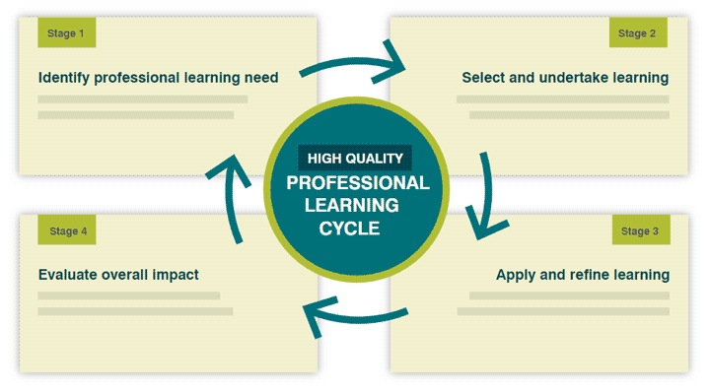
The stages in the cycle are interwoven and may differ according to a teacher’s learning needs and the type of professional learning being undertaken.
Further reading: Read Enabling the High Quality Professional Learning cycle - Considerations for leaders, Improving Teacher Professional Learning and Guide for teachers

Activity for teachers

Stage 1: Identifying your professional learning need(s)

Reflection
What information do you generally consider when identifying professional learning to engage in? How does this compare to your colleagues?

How do your education setting’s current priorities for improvement influence your own goals for professional learning?

How do you consider the current needs of your learners when reflecting on your professional learning goals?

Stage 2: Select and undertake learning
Note Stage 2 and 3 can occur at the same time, depending on what sort of professional learning you are undertaking.
When selecting and undertaking professional learning, you should ensure it is aligned to the Australian Professional Standards for Teachers (the Teacher Standards). When engaging with a learning provider, they should identify which of the Teacher Standards focus areas the session is geared towards. You can then check this against your goals to make sure they align.

Reflection
How do you consider different types of professional learning to select the most suitable one for your learning need(s)?

What types of professional learning do you most commonly engage with; both individually and with your colleagues?

How successfully does your professional learning challenge your thinking and enhance your practice? Why or why not?

Stage 3: Apply and refine learning
Note Stage 3 and 4 can occur at the same time, depending on what sort of professional learning you are undertaking.
After you’ve selected and undertaken professional learning (or while you are continuing to undertake it) you need to apply the learning to your education setting context.
Tips for applying and refining learning:
- Focus on learning strategies you can implement immediately and evaluate in the following weeks.
- You may have to tweak elements to best suit your learners and their context.
- It takes time to become proficient at new strategies, so engage in regular cycles of learning, observation, and review to support and track your progress.
- Seek feedback at key points. This might be from learner data, inviting other teachers to observe the new strategies in action, or discussing what you’ve learnt.
Sometimes the initial professional learning may just be an introduction to a topic, and you may find you need more detail and practical strategies to apply it to the classroom.

Reflection
Reflecting on professional learning you have engaged in recently, what outcomes did you hope to achieve?

What actions did you take to apply that learning within your everyday practice?

Can you identify a time you refined and changed your practice over time as you applied new learning? What information did you consider that guided you to modify your practice incrementally?

Further reading: Read Applying professional learning

Stage 4: Evaluate overall impact
There are many approaches to evaluating professional learning. Measuring effectiveness from multiple viewpoints will provide you with a well-rounded picture.
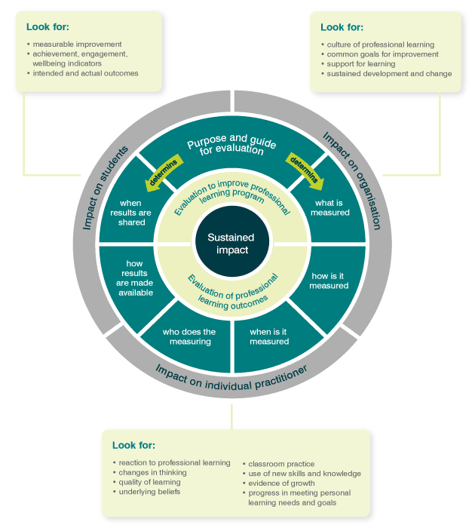
Evaluating is more than deciding if the professional learning was interesting or not. Careful planning and evaluating can help you make decisions about ongoing professional learning and the effects of the changes made to your practice.
Evaluating can take place during and following the learning process.

Reflection
What approaches do you take to monitor whether your professional learning is helping you to improve your practice?

What processes exist at your education setting to help you monitor the impact of changes you make to your practice? For example, what is your approach to sharing your learning experience and evaluation with colleagues?

Further reading: Read Evaluating the impact of professional learning and The Essential guide to evaluation

Resources and downloads
- Enabling the High Quality Professional Learning cycle - Considerations for teachers
- Enabling the High Quality Professional Learning cycle - Considerations for leaders
- Improving Teacher Professional Learning
- How does professional learning support my performance and development?
- Applying professional learning
- Evaluating the impact of professional learning
- The Essential Guide to Professional Learning: Evaluation
- High Quality Professional Learning Toolkit

How-to guides
- Online Learning
- Using social media for professional learning
- Professional Networks
- Professional Associations
- Improve with our coaching resources
- Instructional coaching
- Mentoring
- Mentoring for leadership
- Practical Guide - Inquiry Cycles

Next steps
Move on to:
- Module 2c How can leaders support a high-quality professional learning culture?
Alternatively, return to the:
- Quality Teaching Modules page to select another module.

