Module 2c

How leaders can support a high-quality professional learning culture

Let’s begin
Leaders play an important role in enabling high quality professional learning (HQPL) for teachers through creating a culture of learning that ultimately leads to improved learner outcomes.
A leader can support HQPL by:
- Encouraging ongoing learning and be actively involved
- Encouraging a collective responsibility for learner outcomes
- Establishing high levels of trust
- Establishing structures and processes for HQPL
- Encouraging purposeful collaboration through high levels of interaction and inter-dependence
- Allocating adequate time and resources
- Establishing a strong vision and direction for PL driven by data
- Prioritising the most appropriate and effective types of PL together with teachers
- Aligning the HQPL cycle with existing performance and development processes.

Enabling the High Quality Professional Learning Cycle
This image can be downloaded as an A3 PDF for you to work on in your education setting, alongside your teachers working on their own version.
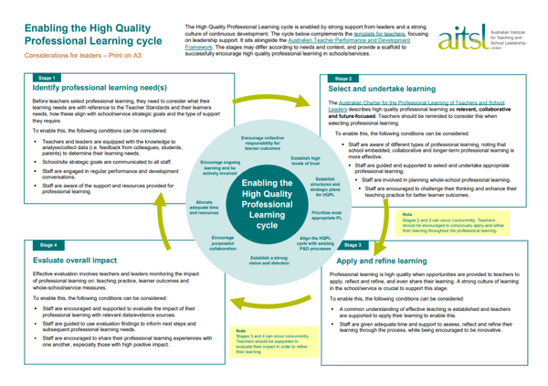
Download and print the Enabling the High Quality Professional Learning cycle PDF

Stage 1: Identify professional learning need(s)
Before teachers select professional learning, they need to consider what their learning needs are with reference to the Teacher Standards and their learners needs, how these align with education setting strategic goals and the type of support they require.
Note in this professional learning we use ‘education setting’ in place of ‘school’, so that teachers across diverse contexts can be included.
Leaders can help teachers identify their learning needs by looking at data from:
- student feedback
- peer/supervisor feedback
- parent feedback
- teacher self-assessment and reflection
- classroom observation reports
- lesson plans
- professional learning conversations and goals
- student data and work samples.

Reflection
What evidence is available to identify the learning needs of teachers?

How are teachers involved in the decision making about their professional learning needs?

How are the strategic goals and initiatives of your education setting discussed with, and communicated to all staff?

How are instructional leaders involved in the process of identifying the professional learning needs of teachers?

How often are teachers engaged in performance and development conversations that encourage professional growth?

What measures are in place to ensure adequate support, resources and time have been allocated for high quality professional learning of teachers?

Stage 2: Select and undertake learning
There is a wide range of approaches for professional learning, with some examples below. This list is non-exhaustive, and there may be overlap.
Classroom-focused
- Observation of practice and feedback
- Coaching
- Mentoring
- Learning events in your setting
- Training courses and workshops
Research-focused
- Professional reading
- Inquiry cycles/action research
- Modules and courses
- Online forums/social media
Community-focused
- Professional learning communities
- Networks
- Collaboration based on work samples
Face-to-face
- External events conferences, training courses and workshops
- Educational setting based events
Online
- Modules and courses
- Webinars/Online forums

The Charter describes high quality professional learning as relevant, collaborative and future-focused. Teachers should be reminded to consider this when selecting professional learning.
To enable this, the following conditions can be considered:
- Staff are aware of different types of professional learning, noting that education setting embedded, collaborative and longer-term professional learning is more effective.
- Staff are guided and supported to select and undertake appropriate professional learning.
- Staff are involved in planning education setting professional learning.
- Staff are encouraged to challenge their thinking and enhance their teaching practice for better learner outcomes.

Reflection
Have you considered different professional learning approaches that best meet the professional learning needs of staff?

How do the identified professional learning needs of staff align with the initiatives and improvement plans of the education setting?

How are teachers informed about different types of professional learning and guided to select appropriate ones?

Are staff aligning professional learning needs with the Teacher Standards?

How can you leverage current expertise within the school to support each professional learning approach?

What school structures and processes can be utilised for different professional learning approaches?

Stage 3: Apply and refine learning
Professional learning is high quality when opportunities are provided to teachers to apply, reflect and refine, and even share their learning. A strong culture of learning in the school, service or education setting is crucial to support this stage. To enable this, the following conditions can be considered:
- A common understanding of effective teaching is established and teachers are supported to apply their learning to enable this.
- Staff are given adequate time and support to assess, reflect and refine their learning through the process, while being encouraged to be innovative.

Reflection
How are teachers made aware of what effective practice should look like in the classroom?

How are teachers supported to apply their learning in phases in order to experience gradual and incremental professional growth?

How has the application of learning contributed to education setting improvement goals?

What systems and processes are in place to support teachers to be innovative, try new strategies, refine them and reflect on their learning?

What formal or informal opportunities are there for teachers to receive feedback, reflect and to challenge their thinking?

Stage 4: Evaluate overall impact
It is important to evaluate the professional learning experience formatively, on three levels:
- education setting support for professional learning
- a teacher’s learning and application of the acquired knowledge and skills
- learner outcomes – whether the professional learning results in the intended change.
Measuring at multiple levels will assist in identifying areas for development and improvement at different stages of the HQPL Cycle. This can guide future refinements to next steps and inform ongoing professional learning needs.
Leaders can gather data from a variety of sources, including learner data and feedback, moderation of learner assessment tasks using work samples, peer/supervisor feedback, parent feedback, teacher self-assessment and reflection, classroom observation reports and teacher perception through surveys etc.

Reflection
What indicators have been selected to measure change in practice from the professional learning?

Do you know which professional learning approaches had the greatest impact on teachers’ and children’s learning and the reason for it?

How are staff being encouraged to review their professional learning experience and share it with their colleagues?

How are you tracking the types of professional learning approaches being undertaken by staff and the content of their professional learning?

What school structures and processes need to be in place to better support teacher professional learning? How can these be evaluated to maximise support for teachers?

Further Reading: Visit the High Quality Professional Learning page to download the leader and teacher templates and an expanded version of this activity.

Further resources and activities

Site-wide professional learning
Site-wide professional learning can create a vibrant culture where staff work together, continually undertake high-quality professional learning, and collaborate in evaluating their teaching impact and learner outcomes.
Read the how-to guide on how to implement site-wide professional learning, from selection through to monitoring.

Charter discussion deck
The Charter discussion deck has six cards, each with questions associated with a key theme from the Charter. Use the questions individually to reflect or use them to have conversations with teachers and other leaders within your education setting.

Essential guides
The Essential Guide to Professional Learning series, with PDFs on Leading Culture, Collaboration and Innovation can be accessed here. Each guide is designed to support leaders in focusing on a particular theme within their education setting’s professional learning.

Video case studies
Explore a range of approaches to implementing a culture of high-quality professional learning as part of the everyday life of your education setting. Link to video case studies
- A Data-Driven, Holistic Approach to Professional Learning St. Joseph's Primary School, ACT
- Focused Professional Learning for Measuring Impact Narrabeen Sports High School, NSW
- Comprehensive Approach to Collaborative Professional Learning Calvary Lutheran Primary School, SA
- Learning Together: A Whole School Focus for Professional Learning Anula Primary School, NT

Professional learning for early childhood, casual/relief and rural, regional and remote teachers
There are additional challenges for professional learning for some cohorts of teachers. The three specific cohorts that have been identified as facing additional challenges are early childhood teachers, casual/relief teachers and teachers in rural, regional and remote contexts.
Read more about how to support these cohorts of teachers.
- How-to guide on Connecting rural, regional and remote teachers to HQPL
- Report on Professional learning for Rural, Regional and Remote Teachers
- Report on Professional learning for Relief Teachers
- How-to guide on supporting your casual relief teachers to learn
- Report on celebrating early childhood teachers

Resources and downloads
- Enabling the High Quality Professional Learning cycle PDF
- High Quality Professional Learning templates, guides and videos

Next steps
Move on to:
- Module 3a to learn how to apply the development cycle to demonstrate proficiency against the Teacher Standards.
Alternatively, return to the:
- Quality teaching modules overview page to select another module.

